TESTING PAWN PROMOTION EOIN DURKIN

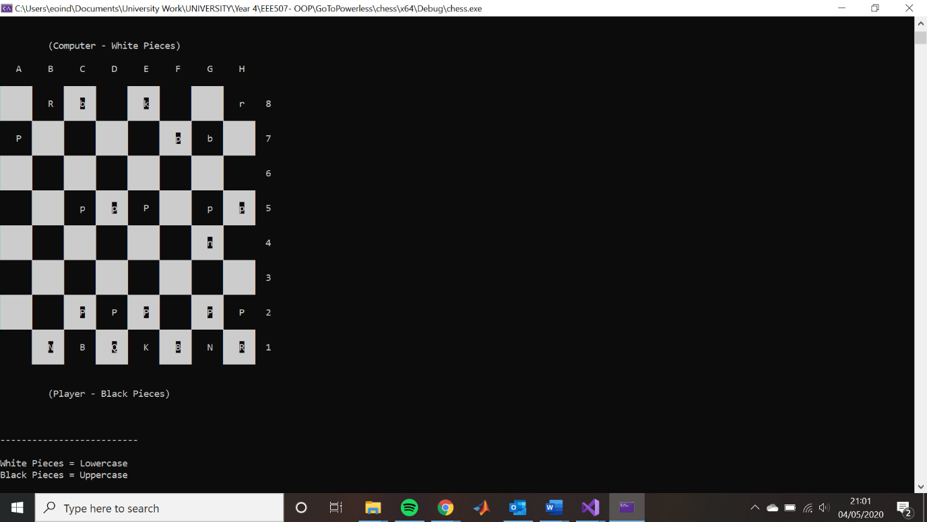The first screenshot shows the black pawn at A7 going to move to A8 and gain pawn promotion

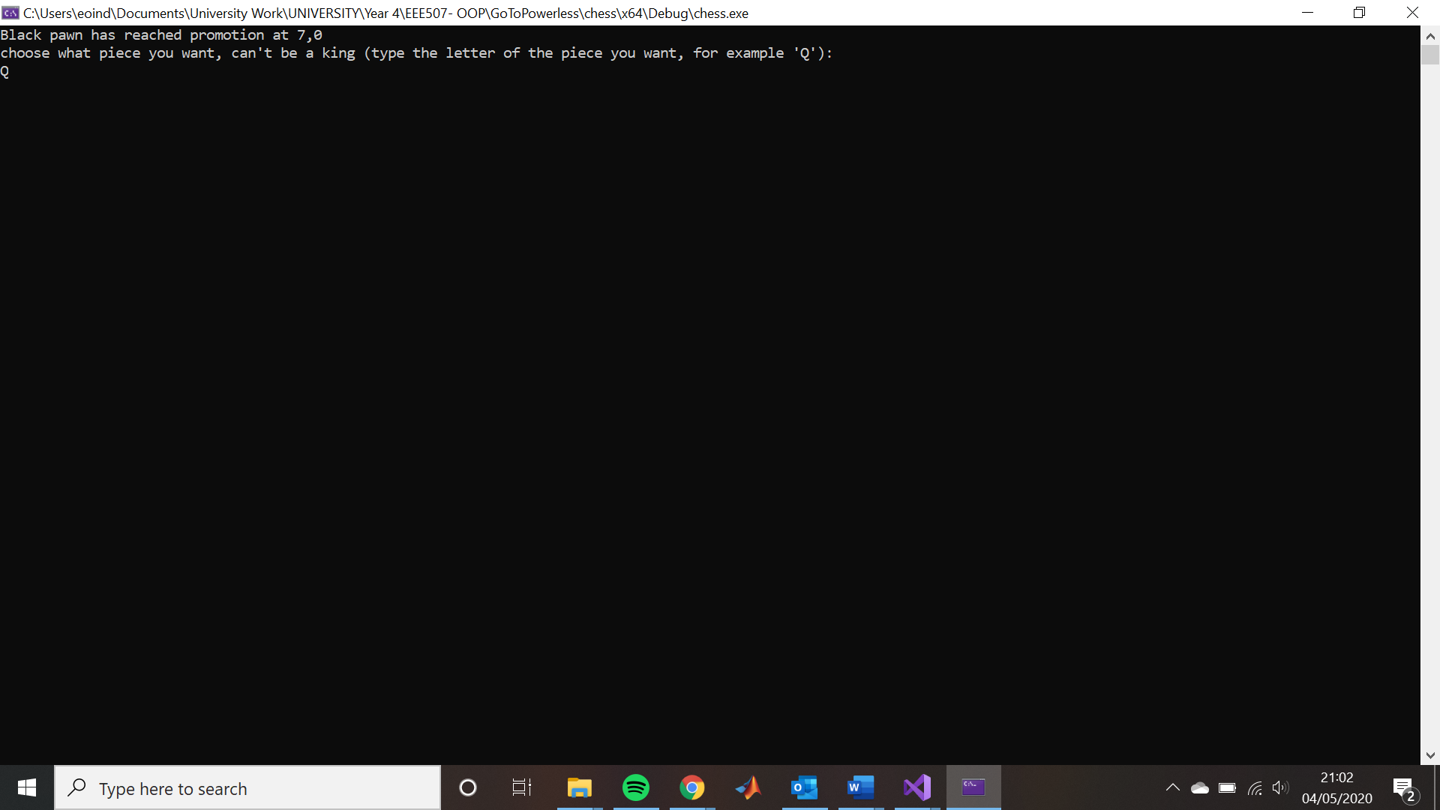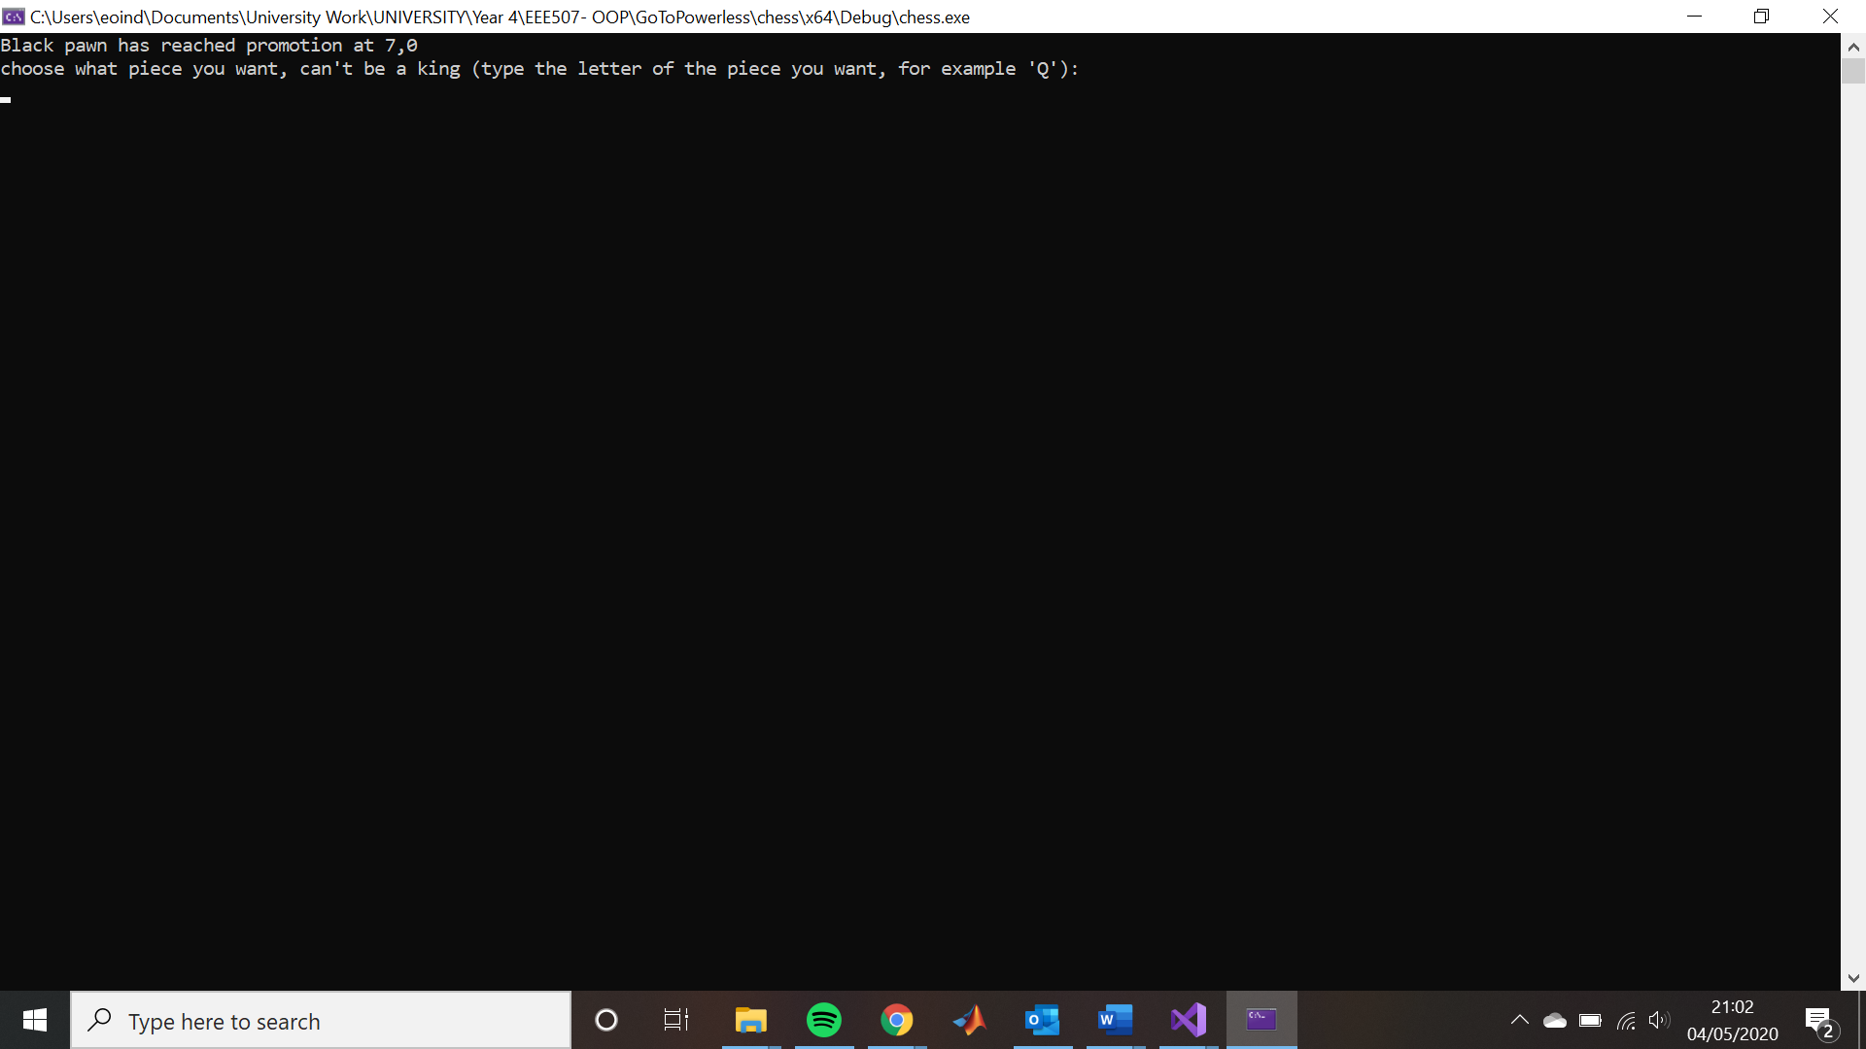Once the Pawn at A7 moves to A8 this message below shows asking for what to promote the Pawn to. In this case I have promoted it to a Queen

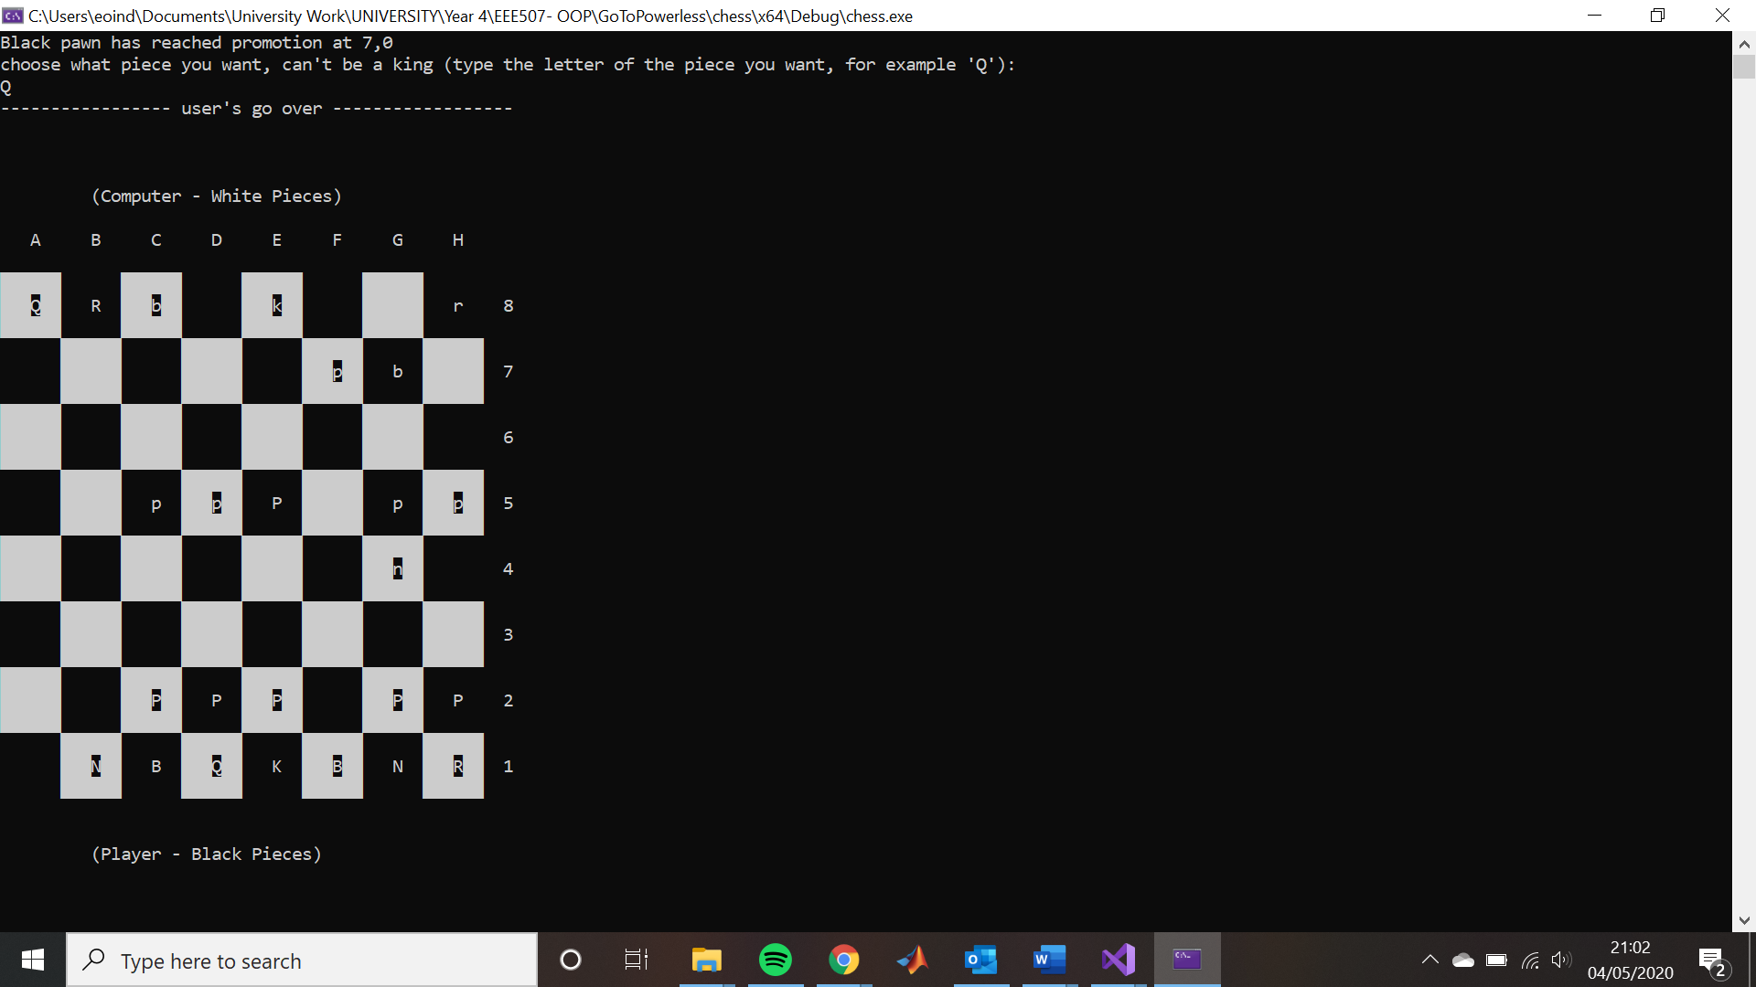This final screenshot shows the black queen in A8 after the promotion.